**DEPARTMENT OF PHYSICS**

**Annual Progress Report (2022-23)**

**Activities of the Department**

1. Department of Physics organized an exhibition of the science projects prepared by the students on 01-04-2023. Around 50 science based projects were displayed in the exhibition.

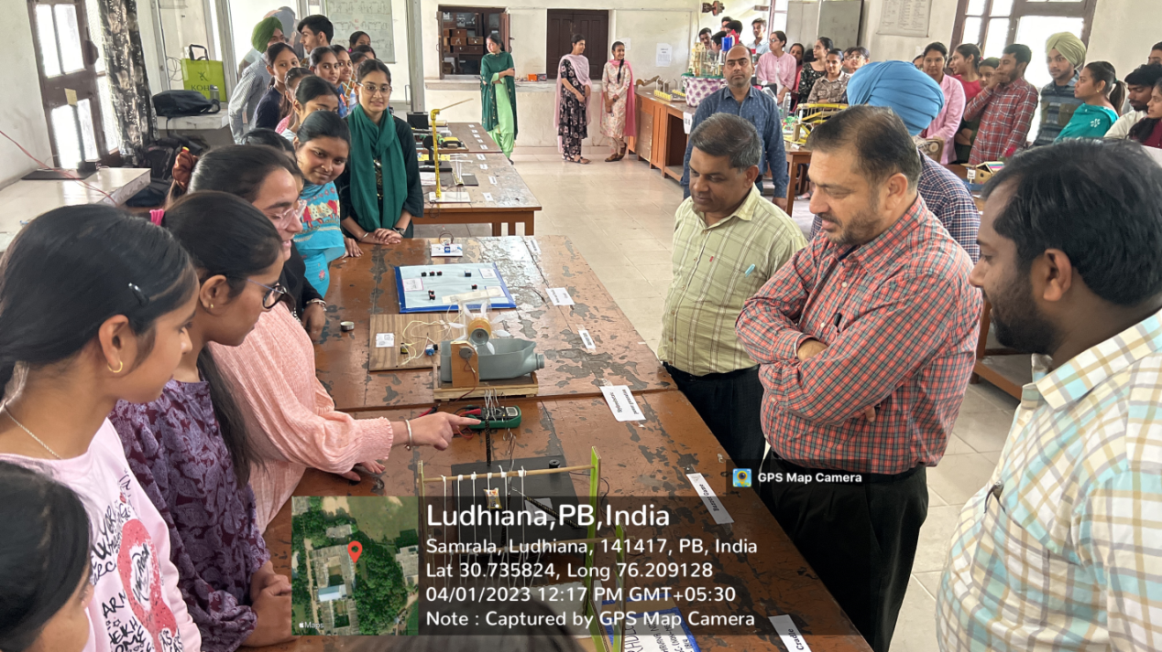

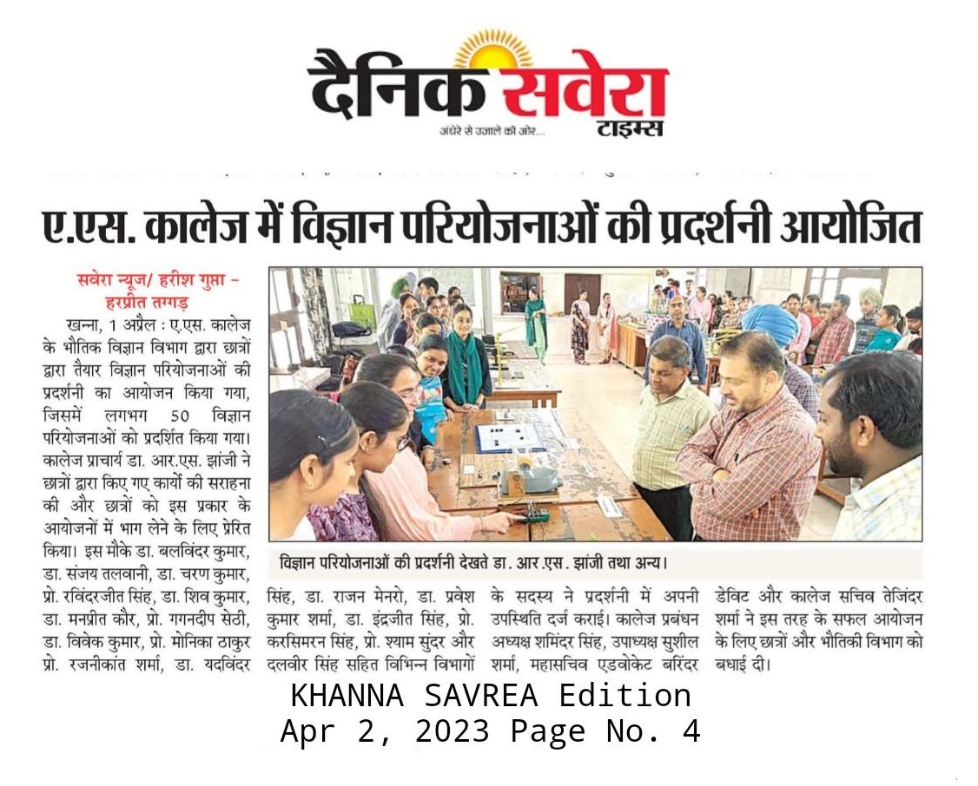

**Achievements and List of Publications by the Faculty (2022-23)**

**Dr. Manish Garg**

1. Elected as a member of the Undergraduate Board of Studies in Physics, Panjab University Chandigarh for the term 01.04.2023 to 31.03.2025.

**_____________________________________________________________________________**

**Dr. Jasdeep Kaur**

1. Dr. Jasdeep Kaur completed her Ph.D. (Physics) from the department of Physics, Lovely Professional University, Jalandhar.

**List of Research papers Published:**

1. Jasdeep Kaur (2023) “An acoustic analysis of fluctuations for inter and Intra speaker variability in speech sound” Journal of Forensic Science and Medicine, 9 (1), pp. 38-43.

____________________________________________________________________________________

**Dr. Mahesh Kumar**

1. Nominated as as a member of the Undergraduate Board of Studies in Physics, Mata Gujri College, Fatehgarh Sahib for the session 2022-23.
2. Attended two days national workshop on Nucleus to Universe: Emerging Future in Stem” Organized by Govt. Women Engineering College Ajmer on 04-05 August, 2022.
3. Participated in Webinar on Blend of Physics and Materials Organized at Department of Physics, Manipal University, Jaipur on 15 September, 2022.
4. Participated in IPA-Young Physicist Meet-02 Organized at Department of Physics, Panjab University, Chandigarh on 09-10 December, 2022.